1. **Video 66: Understanding GitHub**

* Introduction

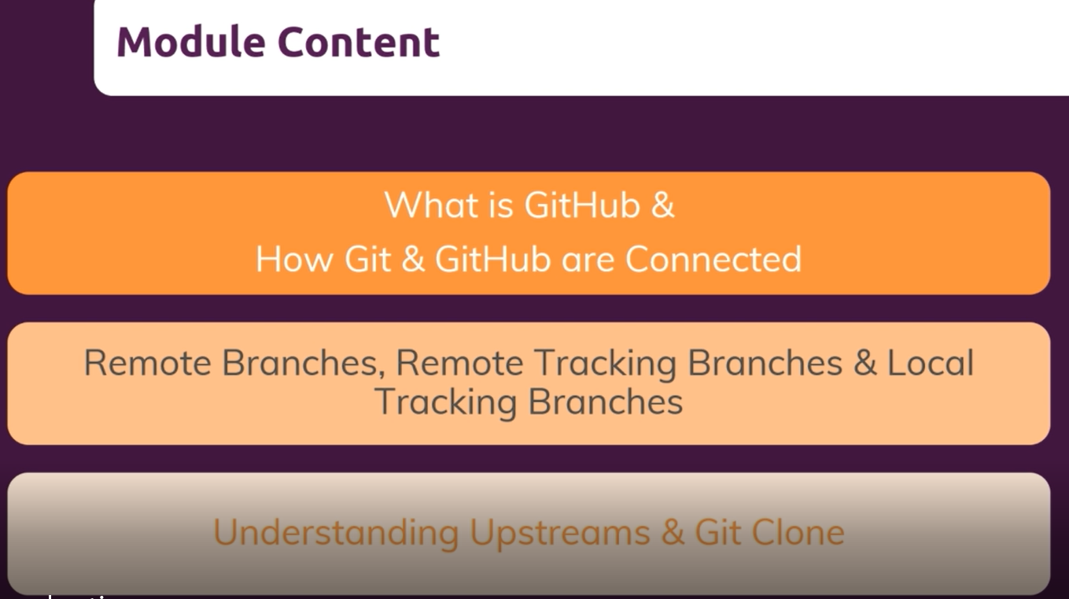

1. **Video 67: What is GitHub**

* Git: Local tool
* Github: Cloud provider for git repository hosting

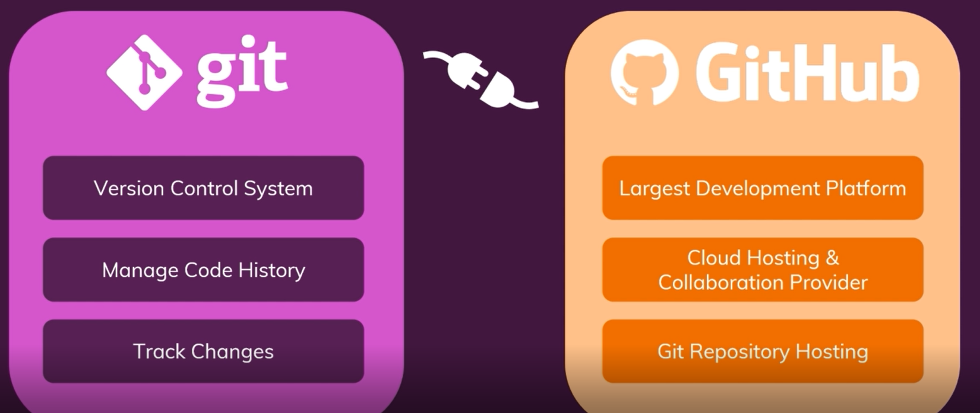

1. **Video 68: 68. From Local to Remote Repository – Theory**

* **git remote add origin URL**: Connects your local repository to your remote repository
* **git push** – pushes your local data to GitHub
* **git pull** – pulls your updated data from GitHub to your local repository

1. **Video 69: Creating a GitHub Account & Introducing GitHub**

* Github.com: Sign up and create an account.

1. **Video 70: Creating a Remote Repository**

* In the GitHub homepage on the left hand side click on Create Repository/New
* Then name your repository,
* Select Public (seen by anyone) or Private (seen by anyone you give access to) repository.
* Add a Readme file
* Then your remote repository is created!

1. **Video 71: Connecting Local & Remote Repositories**

* Create a folder on your desktop
* Go to VSC and pull the created folder
* In VSC, add a Master branch with a text file (M1)
* git init: To initialise the repository
* git add .: Stage your commit
* git commit -m “Commit message”: To commit your changes
* **git remote add origin URL:** connect to you to your remote repository (establishes connection between two repositories)
* **git push -u origin Master**: pushes local data to your remote repository

1. **Video 72: Understanding the Personal Access Token**

* The generate Token tab in the below screen gives access to other contributors and selecting the scope of the access:

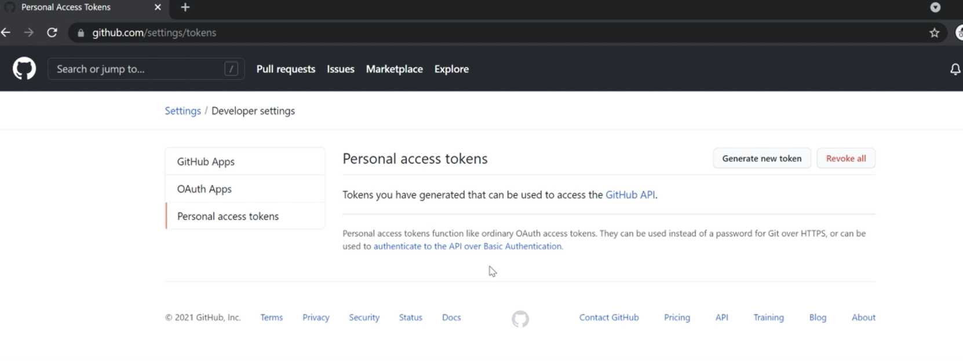

1. **Video 74: Pushing a Second Commit**

* In VSC add a second file in the Master folder
* **git add .:** To initialise
* **git commit -m ”commit message”:** To commit your changes
* **git push origin master:** pushes your changes to the master branch
* **git branch:** shows all branches created in git thus far
* **git branch -a:** shows your local and remote tracking branches

1. **Video 75: From Local to Remote - Understanding the Workflow**

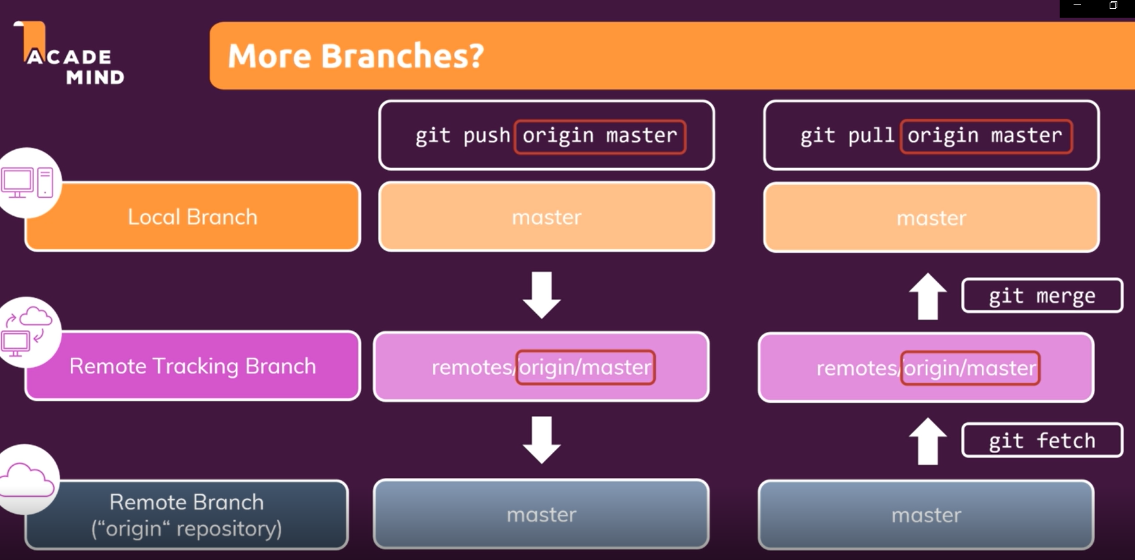

1. **Video 76: Remote Tracking Branches in Practice**

* **git branch -r:** shows all remote tracking branches
* **git branch -a:** shows all local and remote tracking branches
* **git checkout -b [branch name]:** creates new branch and switches to it
* Create files under the new branch
* **git commit -m “commit message”:** tocommit the changes you made
* **git push origin [new branch created]:** to push your changes to the new branch in Github

1. **Video 77: Understanding Local Tracking Branches**

* Overview of branch types

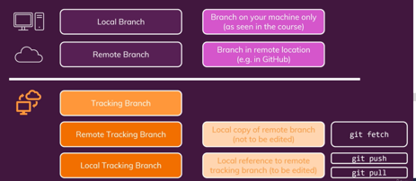

* Local and remote tracking branches

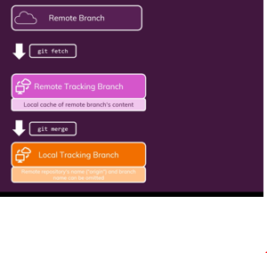

1. **Video 78: Creating Local Tracking Branches**

* **git branch –track [branch name] origin/[branch you are tracking from]:** creates a local tracking branch
* From this branch you are able to pull or push from this branch.
* **git branch -D [branch name]:** deletes a branch
* naming convention of local and remote branch should be the same to avoid confusion.
* git push: updates local branch and pushes work to Github.
* git pull: pulls work from remote branch to local branch.
* **git branch -vv**: gives you more detail on all your local and remote branches

1. **Video 79: Remote & Tracking Branches - Command Overview**

* Local and remote tracking branches

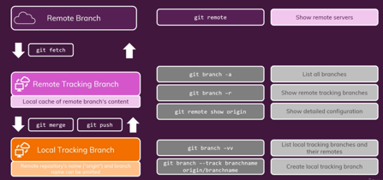

* **Connecting Git and GitHub: Access existing repository**

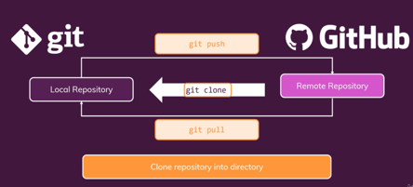

1. **Video 80: Cloning a Remote Repository**

* Copy code from Github repository
* **git clone [url code copied from Github]:** clones repository to local environment
* **git branch –track [branch name] origin/[branch you are tracking from]:** creates a local tracking branch
* **git push origin [local branch name]:** pushes work to a specific local branch]

1. **Video 81: 81. Understanding the Upstream**

* **git push -u origin [branch name]:** pushes work into local branch and to Github

1. **Video 82: Deleting Remote Branches & Public Commits**

* **git fetch origin:** brings back initial state to local environment
* **git branch -D [branch name]:** deletes a branch
* **git branch –delete –remote origing/[branch name]:** deletes a local tracking branch
* **git push origin –delete [branch name]:** deletes a remote tracking branch
* if you delete a remote branch, the remote tracking branch also gets deleted
* **git reset –hard HEAD~1:** Deletes the last commit that you did
* **git push –force origin master:** updates remote branch, showing you the deleted commit

1. **Video 83: Wrap Up**

* **Github Summary**

